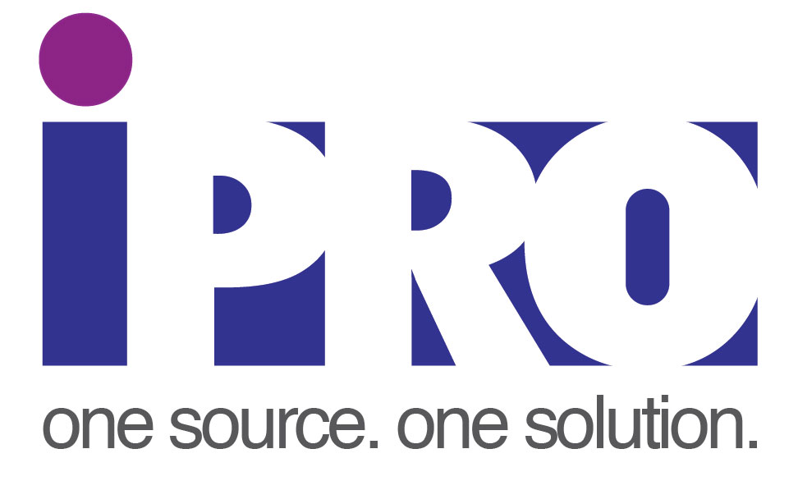

**SUPPLIER HANDBOOK**

**RECORD OF REVISION NUMBERS**

|  |  |  |  |
| --- | --- | --- | --- |
| **Date** | **Revision No** | **Page Nos** | **Reason for re-issue** |
| 21/02/2017 | 1 | All | Initial Issue |
| 03/05/2017 | 2 | 9-11 | Section 8 – PPAP revised. |
| 23/05/2017 | 3 | 9 | Section 8 – tooling added. |
| 23/06/2017 | 4 | All | Various changes made to respond to AS9120 Stage 2 NCs. |
| 06/07/2017 | 5 | All | Finance specifics amended in section 5.3 |
| 24/01/2018 | 6 | All | Updated general items. |
| 25/07/2018 | 7 | All | Policy documents updated, risk management section added. Change to CoC Section |

# Contents

1. Contents 3

2. About iPRO Solutions LTD 4

3. Our Values 5

4. Preface 6

5. iPRO Solutions Supplier Contacts 7

Supplier Quality Representatives 7

Supply Chain Representatives 7

6. Supply Chain Requirements 7

7. Supplier Approval 9

8. Quality Requirements for Delivered Product 10

9. Environmental Requirements for Suppliers 11

10. Tooling 11

11. PPAP Requirements 12

PPAP Requirements 12

Submission Levels 12

Submission 13

12. Requirements for Suppliers of Aerospace/Defence Product 14

13. Code of Conduct & Ethical Policies 14

a. Conflict Minerals 16

b. Child Labour & Slavery 16

14. Supplier Classifications & Development 17

Standard supplier 17

Preferred Supplier 17

Partner Supplier 18

15. Consignment Stock 19

16. Supplier Acknowledgement 21

17. ANNEX 01 22

**ANNEX 02** 23

**ANNEX 03** 24

**ANNEX 04** 25

# About iPRO Solutions LTD

iPRO Solutions is the UK's leading global sourcing and manufacturing provider. We work with some of the UK’s leading industry companies offering a range of services that span the entire manufacturing process, addressing customers’ needs throughout the product lifecycle.

We offer a one point of contact for a wide range of bespoke, high quality engineered components and assemblies including plastics, metals and electronics. Our unrivalled network of suppliers provides simple overseas sourcing with minimal risk, without compromising product quality.

Our team of sourcing experts based across our offices in the UK, China, Malaysia and India have found the best suppliers across the network for an extensive range of industrial components.

Since 2011 we have provided product and final assembly services at our head office in Buckinghamshire, UK. We have the capacity to assemble mechanical and electro-mechanical precision components. At our modern facility, we also carry out CNC Machining, CMM inspection, ultrasonic cleaning, manual and robotic gluing.

iPRO are able to offer our customers a range of logistic solutions, delivering to customer or the end user. Our warehousing service includes maintaining stock levels and generating stock reports.

# Our Values

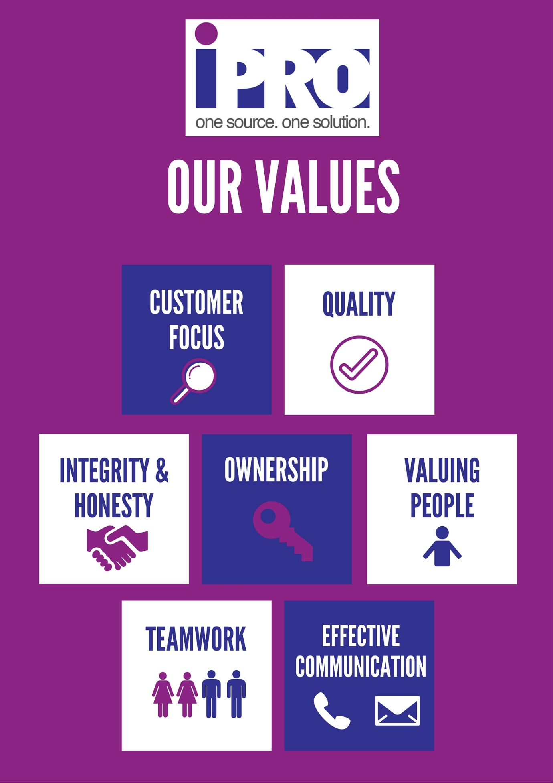

# Preface

These requirements are applicable for all suppliers to iPRO Solutions.

These requirements have been identified to assist our suppliers in understanding the purchasing expectations and quality requirements for products supplied to iPRO Solutions. These are also a tool to assist iPRO Solutions in complying with ISO 9001 & ISO 14001 and to develop our suppliers.

Through implementation and adherence to the requirements stated herein, iPRO Solutions looks forward to a long and mutually beneficial relationship with our suppliers.

# iPRO Solutions Supplier Contacts

## Supplier Quality Representatives

|  |  |  |  |
| --- | --- | --- | --- |
| **Role** | **Name** | **Email** | **Phone** |
| iPRO Group Quality Manager | Nigel Mangnall | [nmangnall@iprosolutions.co.uk](mailto:nmangnall@iprosolutions.co.uk) | (UK) 01844 292630 |
| UK Quality Engineer | Nick Lanigan | [nlanigan@iprosolutions.co.uk](mailto:nlanigan@iprosolutions.co.uk) | (UK) 01844 292630 |
| Malaysia Supplier Quality Manager | CS Neoh | [csneoh@iproprocurement.com](mailto:csneoh@iproprocurement.com) | (MY) 006016 - 475 8735 |
| Malaysia Quality Engineer | Wan Amirul Bakri | [Amirul@iproprocurement.com](mailto:Amirul@iproprocurement.com) | (MY) 006012 - 475 0324 |
| China Supplier Quality Representative | Ben Yao | [Ben.Yao@iproprocurement.com](mailto:Ben.Yao@iproprocurement.com) | (CH) +13503000571 |
| India Supplier Quality Representative | Ankit Daftary | [ADaftary@iprosolutions.co.uk](mailto:ADaftary@iprosolutions.co.uk) | (IN) 0091 0953 5666674 |

## Supply Chain Representatives

|  |  |  |  |
| --- | --- | --- | --- |
| **Role** | **Name** | **Email** | **Phone** |
| Head of Supply Chain | Rebecca Batting | [Rbatting@iprosolutions.co.uk](mailto:Rbatting@iprosolutions.co.uk) | (UK) 01844 292630 |
| Malaysia Supply Chain | Geanise Teoh | [geaniseteoh@iproprocurement.com](mailto:geaniseteoh@iproprocurement.com) | (MY) 0060 4645 7426 |
| China Supply Chain | Orita Liang | [oritaliang@iproprocurement.com](mailto:oritaliang@iproprocurement.com) | (CH) 0086  20  89572586 |

# Supply Chain Requirements

**Order Acknowledgement**

IPRO requires an order acknowledgement within a specified time frame of 24 hours.

The order acknowledgement should contain full detailed part numbers, price, delivery date and any additional charges. If the charge are not on the acknowledgement they will not be paid.

Suppliers are required to alert the purchaser if the delivery is delayed or early.

UK suppliers are required to alert either the supply chain team or warehouse if a delivery is 2 pallets of more up to 24 hours before scheduled delivery.

**Delivery Terms**

All deliveries require a packing list and dispatch note.

IPRO requires all delivery paperwork to contain:

* PO number,
* part number,
* quantity,
* supplier part number,
* description,
* tariff code,
* freight terms,
* weights and dims per pallet or carton
* collection address.

This information is to be clearly labelled on the box and sent via email. Failure to clearly identify goods or supply a delivery note unless otherwise agreed with iPRO SQR shall result in rejection of goods on receipt.

All deliveries to IPRO must:

* be on Euro pallets unless otherwise agreed.
* All pallets must be ISPM 15 compliant.
* Larger deliveries must be booked in with the warehouse for AM/PM delivery slots.
* Deliveries of multiple parts should be separated with one part per pallet.

Labelling must follow IPRO template or agreed format.

iPRO Solutions requires all suppliers to strive for 100% on-time delivery performance with the correct quantity and pricing agreed upon. Individual supplier targets shall be agreed with the relevant iPRO Solutions buyer.

**Invoicing Terms**

All invoices are to be clearly labelled either “Invoice” (financial invoice) or “Commercial Invoice” (raised for shipping purposes only, if the financial invoice does not contain all the required information). All invoices must include the iPRO part number, quantity, unit cost and total value. The shipping terms, currency and iPRO purchase order number must be clearly stated. Invoices cannot be processed if they do not agree to iPRO’s purchase order.

The commercial invoice supplied to the freight forwarder must state the UK tariff code advised to you by iPRO and contain a statement of origin.

If GSP/REX applies for relief of import duty, the correct paperwork must be provided to iPRO. For REX registered suppliers, REX number must be stated on Commercial Invoice.

If supplier is not REX registered and Invoice value is over €6000, original GSP Form A must be sent to iPRO by secure trackable means – emailed copies of GSP Form A are not acceptable. Copies of GSP Form As must be provided to the freight forwarder with the commercial invoice. If we are unable to claim relief of duty due to forms not being received, the supplier will reimburse us for import duty paid. If forms are received late, the supplier will reimburse iPRO for admin costs involved in making a claim for repayment of import duty paid.

All financial invoices need to be emailed to accounts@iprosolutions.co.uk on the date the goods are despatched and statements must also be sent to that email address on the last working day of each month.

**Other Requirements**

* All outworks parts must be relabelled after processing with the new part number.
* Goods must be packaged as greed by IPRO buyer.
* Suppliers must make source that pallets are within specified height and weight range.
* Products should be stackable where possible
* Where product is delayed in shipment due to incorrect information provided by the supplier or the supplier’s failure to produce required information, any costs or penalties incurred by iPRO to resolve shall be chargeable to the supplier.
* iPRO Policy is to Purchase FOB and with payment terms of 60 days EOM. Our policy shall be to pay suppliers on-time. Suppliers delivering late, delivering the wrong quantity, quoting the wrong purchase Order number or having quality problems shall not enjoy a guarantee of on-time payment.

# Supplier Approval

* The use of new suppliers shall require a “DAY-1 commercial audit”, to be completed BEFORE any engagement in business and a “Quality Audit” completed BEFORE any production orders are placed.
* iPRO shall adopt a policy of approving more than one supplier for each part where this is possible.
* All suppliers shall be subject to periodic auditing by iPRO Solutions – the auditing intervals shall be agreed.
* For competitiveness reasons the Sourcing Team are required to re-cost and re-negotiate all materials purchased for re-sale on an annual basis, with new prices and terms becoming effective latest 1st June each year. All key suppliers shall be subject to an annual competitiveness review and negotiation of terms.
* All suppliers shall have a signed NDA as a pre-requisite to commencing any form of exchange of drawings or other confidential documents. All drawings issued to suppliers without NDA’s shall have the name of the customer removed, unless by agreement with the account manager.

# Quality Requirements for Delivered Product

The following are requirements for all deliveries of production parts to iPRO Solutions or on behalf of iPRO Solutions:

* Where requested by iPRO deliveries will be supplied with a Certificate of Conformity – the method of certificate supply shall be agreed when a Purchase Order is placed. Failure to provide this unless otherwise agreed with iPRO SQE shall result in rejection of goods on receipt. The Certificate of Conformity must state what specifications and revision levels have been used to manufacture the products.
* Traceability information as agreed with iPRO Solutions SQE will be retained by the supplier indefinitely unless otherwise agreed. iPRO Solutions may request this information as required. This information can include but is not limited to:
  + Manufacturing records such as maintenance records, inspection data, cpk studies and in process checks
  + Raw material certificates
  + Incoming material inspection
  + Training records
* Disposal of this information shall be done only with approval of the iPRO Solutions SQE. The method of disposal shall be confirmed by iPRO Solutions SQE.
* iPRO Solutions expect all deliveries to be to “Zero Defect” standards in order to meet our and our supplier’s contribution to service conformity & product safety. Verification of product shall be carried out by the supplier in order to meet these requirements. Any deviation from this will result in rejection and return of the product to the supplier with subsequent charges attached. Payment by iPRO Solutions shall not constitute acceptance.
* Test & Verification (including inspection & SPC reports as required) data shall be retained by the Supplier indefinitely unless otherwise agreed with the Supplier Quality Engineer (SQE). Test & Verification requirements will be agreed during the NPI phase with the SQE. iPRO Solutions may request this information as required.
* iPRO Solutions reserves the right of access to any facilities in the supplier’s supply chain and associated documentation for our representatives, our customer, their representatives and appropriate regulatory authorities.
* Should any non-conforming processes, products, or services be identified by the supplier, they must immediately notify the appropriate iPRO representative in writing.
* Where goods are rejected by iPRO Solutions, goods shall be returned to the supplier at the supplier’s cost and a credit for the full quantity will be required. Replacement parts will not be accepted by iPRO Solutions. The supplier will be expected to complete a corrective action report within 14 days, the level shall be agreed with the SQE. An example is included in Appendix 2.
* Parts shall be ROSHH and REACH compliant. Evidence of this must be available on request.
* Product shelf life shall be labelled on the part packaging if required.
* Where British Standards or other specifications are used to manufacture product, the latest revision level must be used unless otherwise agreed with the iPRO SQE.

# Environmental Requirements for Suppliers

In order to maintain our ISO 14001:2004 certification, we expect our suppliers to comply with the following:

* Suppliers shall commit to continuous environmental improvement wherever possible
* Shall be aware of how their businesses and products impact the environment
* Know and comply with all regulatory requirements & iPRO Solutions’ environmental policy
* Notify iPRO Solutions promptly of any significant environmental compliance violations
* Comply with current global classifications of hazardous substances (ROHS II, REACH, etc)
* Supply composition information on parts/components as requested
* iPRO Solutions encourages suppliers to be ISO 14001 certified or have a plan to become certified.
* Use recyclable and renewable materials including packaging wherever possible
* Wooden EURO pallets should be used ONLY for shipments to iPRO Solutions.

# Tooling

Where tooling and fixturing is required to manufacture the product to our specifications, iPRO will pay for tooling.

We expect suppliers to:

* maintain our tooling as per either the supplier’s tool maintenance process or an interval defined by iPRO Engineering as appropriate.
* to provide an asset plate detailing part number and ownership as a minimum.
* provide a statement of tooling condition and shots remaining on 31st August each year. The method of providing this information will be agreed with iPRO Engineering, suppliers are expected to comply with these requests.
* Allow iPRO representatives immediate access to iPRO owned tooling
* Notify iPRO immediately of any proposed changes to iPRO owned tooling. iPRO reserves the right to refuse these changes.
* Notify iPRO immediately of any proposed movement of iPRO owned tooling away from the original agreed manufacturing site.

# PPAP Requirements

The purpose of this section is to inform suppliers of our requirements when submitting (Production Part Approval Process) PPAP documentation and to give our suppliers a clear understanding of:-

• What is expected when submitting PPAP’s

• When you should submit them

• Completion and signing of the Part Submission Warrant form (PSW)

• What the implications are if the requirements are not met

PPAP is required any time a new part or a change to an existing part or process is being planned. It is at the discretion of iPRO to determine when and if a PPAP submission will be required and to what level.

As a supplier to iPRO, you should have the necessary quality systems in place that develops all of the requirements of a PPAP submission, regardless of whether you have been asked to deliver a submission in the past.

In the event that a PPAP has not been previously submitted against a product, iPRO reserves the right to request any of these documents at any time during the life of the product.

Following approval of the PPAP, suppliers shall not make changes to their processes, location, facilities, equipment, material, product design (or any change which may affect product design or function) without written approval from iPRO.

The following table should be used to assess the need to inform iPRO of changes to processes or tools that affect iPRO parts.

|  |  |  |  |
| --- | --- | --- | --- |
| # | Requirement | Notify iPRO | PPAP |
| 1 | Use of alternative material other than approved material | X | X |
| 2 | Production in new location or using new equipment | X | * |
| 3 | Production from new tools |  | X |
| 4 | Production from repaired tools | X |  |
| 5 | Process change – other than note 2 | X | * |
| 6 | Production from equipment that has been inactive for 12 months or more | X |  |
| 7 | Changes in sub contractors/suppliers | X | X |

*Note – iPRO reserve the right to request a PPAP at their discretion for these requirements.

## PPAP Requirements

## Submission Levels

Submission Levels define which elements should be submitted. The level shall be determined by iPRO Quality Department, however default unless otherwise agreed shall be level 3.

The following table shall be used to determine what is required for each PPAP level:

|  |  |  |  |  |  |  |
| --- | --- | --- | --- | --- | --- | --- |
| # | Requirement | Level 1 | Level 2 | Level 3  Default | Level 4 | Level 5 |
| 1 | **Samples** |  | **✓** | **✓** |  | **✓** |
| 2 | **Latest Level Drawings** |  |  | **✓** | **✓** | **✓** |
| 3 | **Dimensional Results (& Cpk on CC’s)** |  | **✓** | **✓** | **✓** | **✓** |
| 4 | **Material Analysis** |  | **✓** | **✓** | **✓** | **✓** |
| 5 | **Performance Test Results** |  |  | **✓** | **✓** | **✓** |
| 6 | **Master Samples** |  | **✓** | **✓** |  | **✓** |
| 7 | **Design FMEA (If Applicable)** |  |  | **✓** | **✓** | **✓** |
| 8 | **Process FMEA** |  |  | **✓** | **✓** | **✓** |
| 9 | **Initial Process Studies** |  |  | **✓** | **✓** | **✓** |
| 10 | **Measurement Systems Analysis** |  |  | **✓** | **✓** | **✓** |
| 11 | **Control Plan** |  |  | **✓** | **✓** | **✓** |
| 12 | **Standard Operating Procedures (SOP’s)** |  |  | **✓** | **✓** | **✓** |
| 13 | **Laboratory Data** |  |  | **✓** | **✓** | **✓** |
| 14 | **Appearance Approval Report** | **✓** |  | **✓** | **✓** | **✓** |
| 15 | **Fit & Function Analysis** |  |  | **✓** | **✓** | **✓** |
| 16 | **Certificate of Conformity** | **✓** | **✓** | **✓** | **✓** | **✓** |
| 17 | **ROSH** |  |  | **✓** | **✓** | **✓** |
| 18 | **REACH** |  |  | **✓** | **✓** | **✓** |
| 19 | **Tooling** |  |  | **✓** | **✓** | **✓** |
| 20 | **Life Cycle Testing** |  |  | **✓** | **✓** | **✓** |
| 21 | **Packaging Specification** |  |  | **✓** | **✓** | **✓** |
| 22 | **Part Submission Warrant (PSW)** | **✓** | **✓** | **✓** | **✓** | **✓** |

## Submission

* All PPAPs shall be submitted electronically.
* Submissions must be submitted on time.
* Any data used in the PPAP (e.g. dimensional data) shall be submitted from a production run of at least 100 parts sampled randomly. This production run shall be manufactured using standard equipment, tooling, conditions and staff unless otherwise agreed.

# Requirements for Suppliers of Aerospace/Defence Product

The following are requirements for any suppliers providing Aerospace & Defence product to iPRO Solutions under our AS9120 Certification:

* Suppliers shall be expected to comply with the guidelines of the appropriate Aerospace Quality Management System Standard such as AS9100 unless otherwise agreed and approved by the Engineering Manager.
* Suppliers shall be expected to comply with any additional requirements which are cascaded down from iPRO Solutions’ customer
* All supporting documentation shall be submitted prior to shipment of Aerospace & Defence product. This shall be approved by iPRO Solutions Quality Assurance before shipment.
* Acceptance of product shall only be on iPRO Solutions inspection approval.
* Suppliers shall be expected to retain all documented information associated with production of Aerospace & Defence product as agreed with iPRO Solutions Quality Assurance
* Suppliers shall develop, implement, and maintain methods and processes appropriate to their products to minimize the risk of introducing counterfeit parts and materials and suspected unapproved parts & materials into deliverable products. Effective processes should be in place to detect counterfeit/suspected unapproved parts and materials, provide notification to recipients of counterfeit/suspected unapproved product(s) when warranted, and exclude them from the delivered product. iPRO shall be notified immediately should any suspected counterfeit/unapproved parts be detected.

# Code of Conduct & Ethical Policies

iPRO has an obligation to ensure that business partners do not act in a manner contrary to the UK Bribery Act 2010 on our behalf.

The Act came into force in the UK in July 2011. For the first time in the UK, it became specifically illegal for companies to benefit from bribery wherever in the world it occurs. It also requires commercial organisations to take steps to prevent bribery by their employees and agents or business partners when the latter could be seen as representing that company.

iPRO is committed to going beyond the legal minimum; however this section is intended to inform our business partners of the main provisions under The Act relevant to iPRO and its suppliers.

* It is an offence to bribe another person by promising or giving a financial or other advantage to any other person with the intention of inducing that person to perform improperly a *relevant function or activity* either in advance of afterwards.
* It is an offence to promise or give a financial or other advantage to another person knowing or believing that acceptance of the advantage is itself constituting improper performance.
* It is an offence to ask for, agree to receive or receive a financial or other advantage as a reward for improper performance of a relevant function or activity.
* It does not matter if the person offering the advantage is the one directly benefiting, or if it is intended for a third party to benefit. An offence has been committed nonetheless.
* It does not matter if the person asking for, agreeing to receive or receiving the advantage does so through a third party. An offence has been committed nonetheless.
* Bribery committed both inside and outside of the United Kingdom and by both public and private sector organisations are covered by the Act.

A relevant function or activity is:

* Any function of a public nature
* Any activity connected with a business
* Any activity performed in the course of a person’s employment
* Any activity performed by or on behalf of the company

The tests of whether an offence is committed by are person are:

* A person performing the function or activity is expected to perform it in good faith
* A person performing the function or activity is expected to perform it impartially
* A person performing the function or activity is in a position of trust by virtue of performing it

Expectation test:

* The test of what is expected is a test of what a reasonable person in the United Kingdom would expect in relation to the performance of the type of function or activity concerned

A company is guilty of an offence if:

* A person associated with it bribes another person with the intention to retain the business for the company or to obtain or retain an advantage in the conduct of the company’s business

The only defence for a company is to:

* Prove that it had in place the adequate procedures designed to prevent people associated with it from undertaking such conduct

All of the new offences will have extra-territorial application. Offences will be prosecuted if the alleged to be committed in any of the following ways:

* By a British National or Company
* By a person who is ordinarily resident in the UK
* If the alleged offence occurs within the UK
* If the alleged offender is a company and they have a business presence in the UK regardless of where the bribe is paid
* If an offence occurs overseas, there may also be local legislation that will apply as well as the above.

An example of a situation where iPRO could be prosecuted due to the actions of a business partner is where an introducer pays a bribe to a decision maker at a prospective client to choose iPRO over another finance provider.

iPRO is committed to dealing transparently with all business partners and it is expected that key terms of business are confirmed in writing, and that business partners are aware of our zero tolerance approach to bribery offences or behaviour contrary to this policy from partners or those who purport to represent us.

## Conflict Minerals

**Background**

We are committed to ensuring the health, safety and protection of people who come into contact with our products and business, and we require high social, environmental and human rights standards among our suppliers. Managing our obligations in relation to Conflict Minerals is a part of this corporate responsibility.

**IPRO SOLUTIONS LTD’s commitments**

We are working towards ensuring that our products do not contain Conflict Minerals that have been sourced from mines that support or fund conflict within the Democratic Republic of Congo or adjoining countries. Therefore we are committed to:

- identifying which IPRO SOLUTIONS LTD products are impacted and targeting our efforts accordingly

- not buying products and materials containing Conflict Minerals directly from Conflict Mines

- asking our suppliers to work towards ensuring that any Conflict Minerals contained in the products and materials supplied to IPRO SOLUTIONS LTD originate from Conflict Free sources

- Contributing to conflict-free trade by encouraging our suppliers not to discriminate against legitimate sources of Conflict Minerals. In addition, we are committed to engaging with our customers regarding their disclosure obligations

**IPRO SOLUTIONS LTD’s measures**

In working towards these commitments, we have taken a number of steps that include:

- Engaging with our suppliers so that they respond in a timely manner to our requests for evidence of compliance. In the future, our suppliers’ willingness to comply with this initiative will be a factor in our sourcing decisions

- updating the IPRO SOLUTIONS LTD Supplier Code of Conduct and our purchasing terms and conditions to reflect this policy

Like many other companies tracing Conflict Minerals, it will take time for us to collect the information needed for us to fully understand our use of Conflict Minerals and therefore be able to address all related customer concerns.

## Child Labour & Slavery

**Labour and Human Resources:**

**Labour Laws.**

Suppliers are expected to comply with all local country labour and human resource laws and regulations, including those related to wages, hours worked, working conditions and child labour. Suppliers are expected to adopt sound labour and human resource practices and treat their workers fairly. Specifically:

**1. Employment Practices**

Suppliers must hire and employ workers in compliance with applicable laws. Wages, benefits, and working hours are expected to be fair and reasonable in the local labour market.

**2. Child Labour**

Suppliers must comply with the applicable local laws with regard to the minimum hiring age for employees. If no such law exists or if the existing law permits the hiring of child labour younger than 18 years of age, the supplier may not employ child labour under 16 years of age to work on iPRO Solutions LTD projects. The supplier may hire child labour between 16 and 18 years of age to work on iPRO Solutions LTD projects only if the supplier implements and maintains, in addition to the general standards for environmental, health and safety identified above, all working conditions needed to adequately protect the safety and health of each such child.

**3. Forced Labour (Slavery)**

iPRO Solutions LTD expects suppliers to not use labour that is a result of mental or physical coercion, physical punishment, slavery or other oppressive labour conditions. Suppliers and their employees cannot engage in any form of human trafficking. This prohibition includes not only forced labour and other forms of coercive conduct but also the recruitment, harbouring, transportation, provision, or obtaining of persons for commercial sex acts and the legal or illegal procurement of sex acts for anything of value.

**4. Discrimination**

Suppliers must respect the right of every person to participate in all aspects of employment without regard to their personal characteristics or beliefs (for example, their race, religion or sex). Suppliers’ policies and practices should result in employment decisions being made on the basis of workers’ ability to do the job, and not on their personal characteristics or beliefs.

**5. Freedom of Association.**

Suppliers must respect workers’ right to associate freely, in compliance with existing local laws and without intimidation, reprisal or harassment.

# Supplier Classifications & Development

All suppliers shall be classified into one of three groups:

1. Standard Supplier
2. Preferred Supplier
3. Partner Supplier

## Standard supplier

An everyday supplier, UK or overseas.

## Preferred Supplier

Preferred suppliers are highlighted as part of our commodity strategies for development. They will have formally agreed to our day-1 requirements and in addition will be meeting more strenuous requirements and will receive priority to receive RFQ’s. iPRO will create a Development Plan for each Preferred supplier based on some or all of the following:

* Meets our commercial requirements
* Meets QCD performance targets
* Shows Management commitment to iPRO
* Participates in the annual cost cycle
* Rebate on growing spend
* Demonstrates commitment to NP
* Brings new cost reduction ideas
* Provides outstanding customer service
* Provides fully detailed cost models
* Adopts electronic trading
* Provides consignment stocking
* Commits to a 3 day quotation process
* Signs a Purchase agreement
* Promotes continuous improvement
* Provides technical support
* Supply Chain Optimisation

## Partner Supplier

Partner Suppliers will be true business partners, based on business growth, technical cooperation and enhancing profitability. We will have a formal business agreement for mutual business gain. Openness, technical co-operation, commercial cooperation, business synergy, shared marketing initiatives, rebates, strong senior management relationships and a shared vision will all be in evidence. iPRO will create a Development Plan for each Partner supplier including some or all of the following:

* Meets commercial criteria
* Meets preferred supplier criteria
* Agrees to a commercial sales relationship
* Forms a strategic relationship
* Shares the burden of sales & marketing
* Shows strategic commitment to iPRO
* Displays a shared vision
* Displays openness / Trust
* Provides Technical co-operation on NPI
* Commercial cooperation / Business synergy
* Shared marketing initiatives
* Strong senior management relationships

The above classifications define a tiered approach to promote graduated and closer working relationships with suppliers who are strategic, financially important, and critical to the business or our financial wellbeing.

# Consignment Stock

Where possible/practical, agreements should be negotiated to employ the use of Supplier Consignment Stock on site at iPRO premises.

The iPRO/Supplier consignment process will be employed and followed unless expressly stated in the Supplier Consignment Stock clause of the supplier agreement. A clause in the Supplier agreement will be agreed to employ the use of Supplier Consignment Stock on site at iPRO premises.

The supplier owns right and title to the items described on the Supplier Consignment stock list, and iPRO takes possession of the Consigned stock with the intention of purchasing the stock at the agreed price after to selling them to a third party.

The Supplier grants to iPRO the exclusive right to sell the Consigned stock. Within 30 days EOM from the purchase of the Consigned stock, iPRO will pay the supplier for the items at the agreed purchase price. iPRO will guarantee that sufficient insurance coverage to compensate the supplier for the agreed purchase price of the Consigned stock in the event of damage due to fire, theft, or otherwise.

iPRO will agree that the Consigned stock shall only be kept and stored at addresses that are used in iPRO’s day to day business unless otherwise agreed upon by the supplier in writing.



# Risk Management and Disaster Recovery

The Supplier shall identify and prioritize risks affecting delivery of Products or Services to iPRO.

The Supplier shall, upon request, provide iPRO with proper contingency plans for the highest ranked risks to assure no interruptions of delivery.

The Supplier shall maintain a documented Disaster Recovery Plan to recover business infrastructure in event of disaster. This shall include actions intended to minimise disruption to any iPRO requirements and shall be made available to iPRO on request.

# Supplier Acknowledgement

**Confirmation**

We hereby confirm that we have received and we understand the Supplier Handbook.

We agree to meet these requirements, in all our facilities working to produce products for iPRO Solutions and its customers.

We understand that it is our responsibility to ensure that only the latest revision of this handbook is used.

|  |  |
| --- | --- |
| Supplier’s Full Company Name |  |
| Supplier Address |  |
| Submitted by (name) |  |
| Function |  |
| Email address |  |
| Date and signature |  |

# ANNEX 01



## **ANNEX 02**



## **ANNEX 03**

Vision Statement

To be the leading contract manufacturer for SMEs within UK and Europe

Policy Statement

iPRO Solutions Ltd. & iPRO Manufacturing Ltd. provide procurement and manufacturing solutions to customers through our UK based assembly facility and a global network of supplier partners. We recognise the disciplines of health & safety, quality and environmental management along with social accountability to be the fundamental principles and key to the success of our business.

We plan for controlled sustainable growth in the UK supply & manufacturing market.

The objectives below are set and actioned to achieve this goal.

* Comply with all applicable laws, regulations and standard requirements
* Follow the concept of continuous improvement through the plan-do-check-act cycle
* Make best use of its management resources
* Prevent pollution, minimise wastage & reduce our impact on the environment
* Prioritise Health & Safety through all our business activities ensuring a safe environment for employees, associates, subcontractors, suppliers & neighbours
* Maintain all external 3rd party certification
* Train and develop all staff to ensure required skills are in place

By working to these objectives iPRO aim to increase customer satisfaction and grow in line with our core values of:



Corporate performance indicators are set, monitored, regularly reviewed and actioned.

Cascading down from these are department and individual KPI’s.